Bears of the Rising Sun
Family: Species: Common Name: Capacity:
Ursidae Helarctos malayanus Sun Bear 1.1.offspring

Description
Bears of the Rising Sun was completed in 2014. It was opened by Steve Leonard and sponsored by Tiptree Jam. Colchester Zoo supports Free the Bears through its charity Action for the Wild. The bears, Jo Jo and Srey-Ya were rescued by Free the Bears in 2006 & 2007 respectively.
The objectives of the sun bear exhibit are to maximise the breeding potential of the bears and to engage and inspire visitors to help conserve the species in its native habitat. Also located in the top viewing area are the Rufous Hornbills.
The exhibit consists of a large outside enclosure, indoor house and off-show dens. The bears have access to all of the exhibit all of the time except when keepers are cleaning. The only exception to this is when high winds are forecast and the bears only have access to their indoor areas. They have tunnels connecting indoor and outdoor areas. They access their off-show dens via slides behind the waterfall in the house. The dens consist of 4 individual spaces which can be separated if necessary. Three are mesh walled and the fourth solid walled providing an enclosed cubbing area if the female was to fall pregnant. Keepers have CCTV cameras in all areas of the dens and can view this remotely from keeper areas.
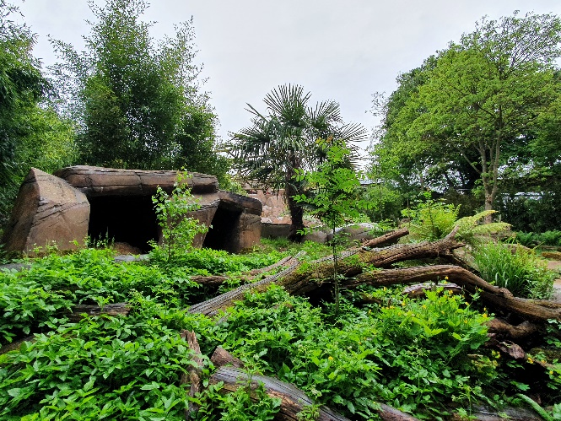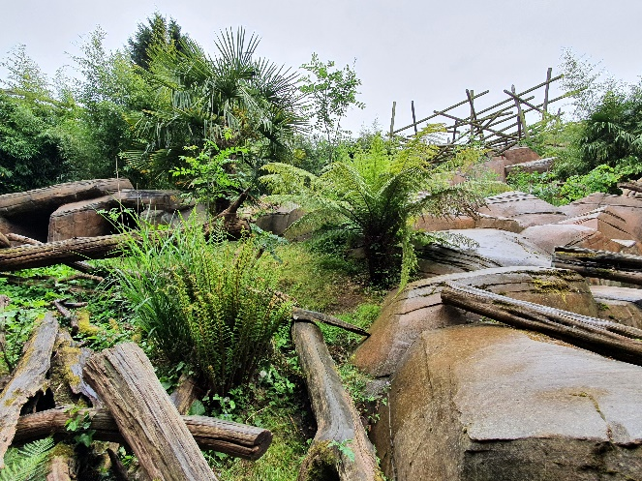

Outside Enclosure
This is a large area with mixed substrates on a steep incline, enclosed by high wooden and mesh fences along with an electric fence. Keepers check the perimeter daily and cut back vegetation from the fenceline along with testing the electric fence. There are two large trees in the enclosure, but for safety reasons, the bears don’t have access to them and they are surrounded with electric wires.
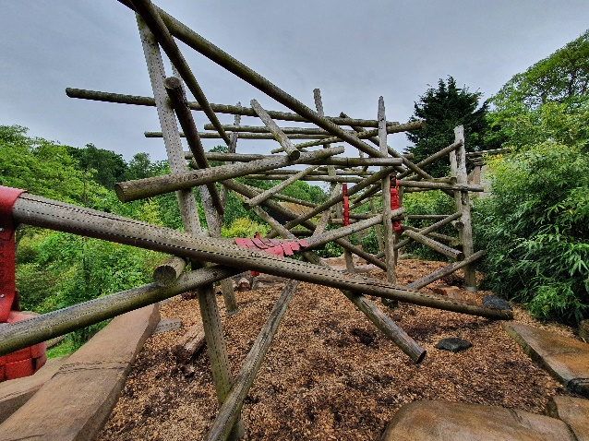
At the top of the enclosure is a large barked area with complex climbing frame. Keepers can secure a range of enrichment to the climbing frame to encourage the bears to climb which is a natural behaviour. Sun Bears are classed as semi-arboreal in the wild. There are boulders across the whole enclosure to encourage climbing and muscle use, as well as large logs which encourage foraging. Keepers can use these to hide food and enrichment under. In front of the top viewing area windows are two ‘wobble trees’ which are used as a form of enrichment to mimic natural behaviours. These are metal structures with a platform on top with holes in to allow the food to drop out when the bears wobble them.
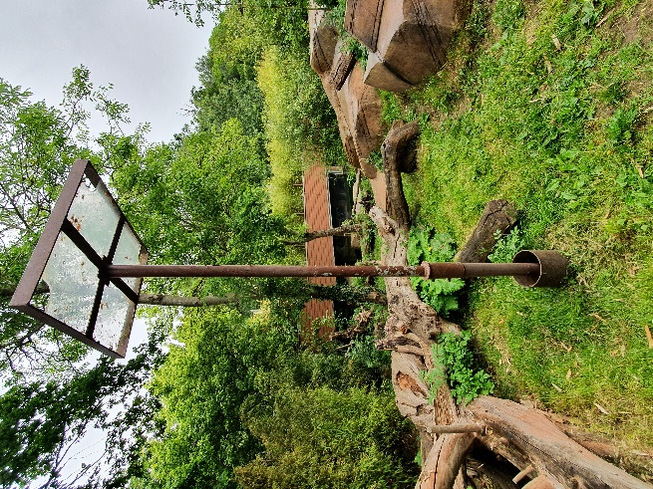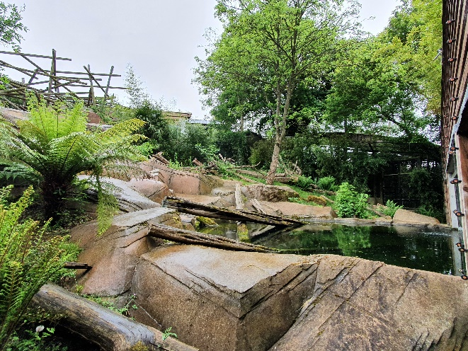
There is a large waterfall descending through the enclosure with three pools. Two of these are shallow which the bears can paddle in to cool off in hot weather. Sun bears are not good swimmers so will not enter the deep pool at the bottom of the enclosure. This deep pool is viewed through an underwater viewing window at the bottom bear viewing area. The pool contains live fish; roach and minnows, but these are safe from the bears as the pool is so deep. The waterfall has a filtration and UV system which is regularly monitored.
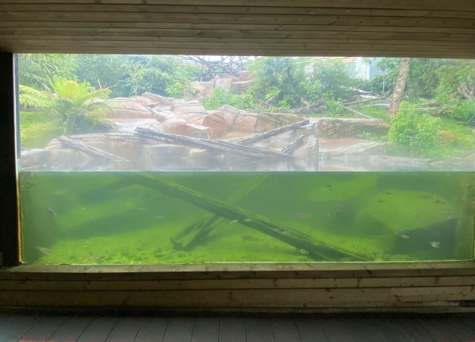
There are two caves at the bottom of the enclosure which provides an option for outside shelter if the bears choose not to go inside.
The perimeter fence is surrounded by bamboo. Majority of the vegetation is bamboo, along with ferns and palms, which are regularly pruned by keepers but offers shelter and screening opportunities for the bears.
Keepers have two access points to the enclosure, one at the top, used on a daily basis for cleaning, feeding and providing enrichment. They have a second access point at the bottom of the enclosure if needed. This is on the right hand side of the enclosure when viewed from the bottom viewing area. This gate also acts as a training wall for the bears with scales built into the enclosure. From the public viewing area this looks like a square metal platform. The scales are operated from outside of the enclosure. This training area is used at least once a week for public to view the bears doing a training session.
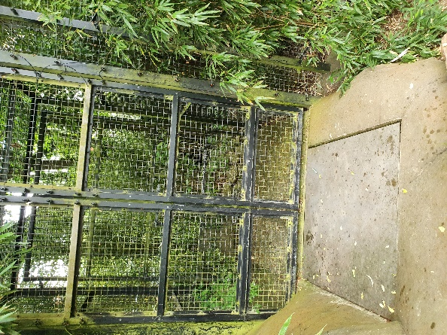

Indoor House
The indoor house is a barked area with a second complex climbing frame. There are large skylights to provide plenty of natural light in addition to electric lights. There are two heaters enclosed in mesh cases on the wall to provide optimal heating conditions. These are operated by a thermostat but can be altered if needed. These are most important during the winter months. Heating is provided by a biomass pellet burner, located outside of the enclosure, near to keeper areas. Ventilation is provided by the bear’s access tunnels.
Attached to the climbing frame are two hammocks to allow the bears somewhere to rest off the ground as they would do in the wild. Woodwool and foliage is provided as bedding material. In the wild sun bears would collect their own bedding materials and make nests. Directly in front of the public viewing windows is a large ‘hot rock’, which has underfloor heating to encourage the bears to sleep on it. Keepers have often seen the bears sleeping or resting on the hot rock. If not there, then the bears are usually found resting in their hammocks or up high on the beams of the climbing frame.
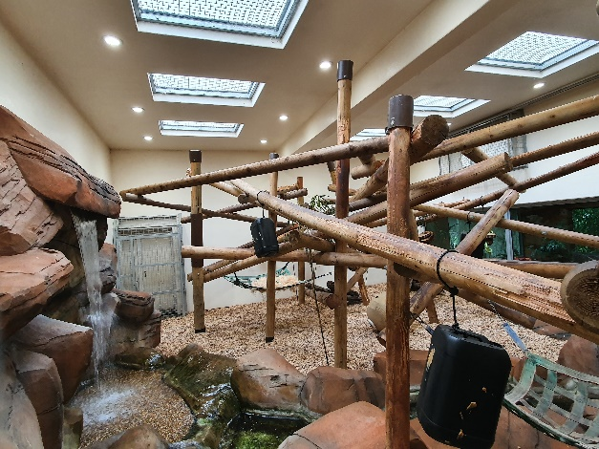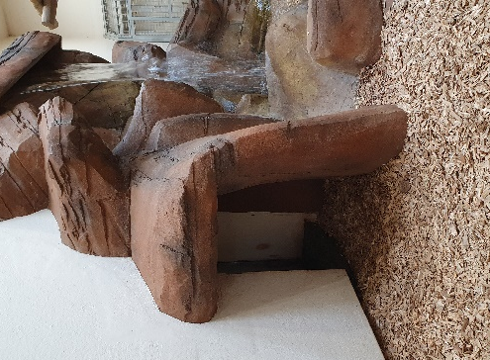
There is a large waterfall in the house which flows into a small pool. This primarily acts as a sound barrier for the bears in case of heavy visitor numbers in the public viewing area. This is cleaned regularly and controlled from keeper areas.
There are multiple large logs which offer foraging opportunities and keepers can hide food underneath. Keepers can also attach enrichment to the climbing frame, similar to outside, to encourage natural climbing behaviours.

Dens
The off-show dens have solid floors with a surface that can be easily cleaned. They are separated into 4 smaller areas, three with mesh walls and one with solid walls, acting as a secluded cubbing area. The bears have access via a number of traps, but don’t have access into the cubbing area. This would only be used in the case of a pregnant female and the male would not have access there at all. In the three main den areas, there are platforms and hammocks in each area which are made out of firehose or wood. Woodwool and foliage is provided as bedding material. Keepers often observe the bears using this material to create nests.
There are two heaters enclosed in mesh cases on the wall to provide optimal heating conditions. These are operated by a thermostat but can be altered if needed. There are electric lights in the dens and all lighting, heating and CCTV are controlled by keepers from outside of the enclosure so they don’t disturb the bears. There are windows to provide ventilation during the summer months.
The cubbing den is split into two areas, one of which would have bark substrate and/or bedding material. There are also infra-red lights in that area.
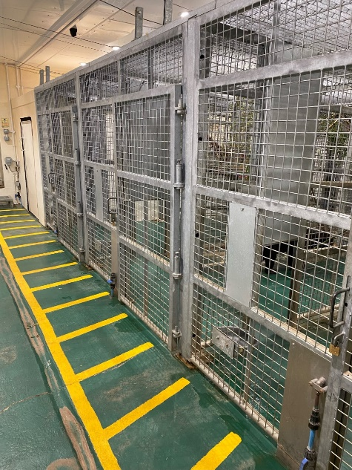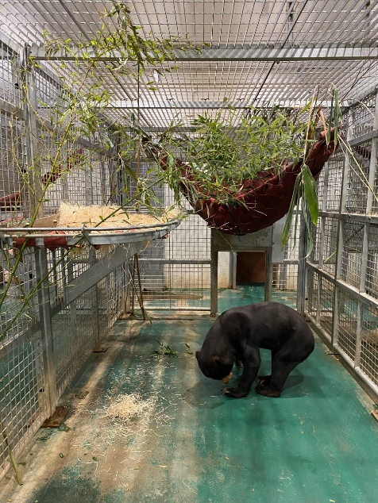
Keeper areas
Keepers have a small kitchen area where they prepare the bear’s food and enrichment. There is fridge for storing food and freezers if needed. During the summer keepers will make frozen enrichment items for the bears.
This area also contains controls for both waterfalls, along with heating, lighting and CCTV. There is also space for storing enrichment.

Security & Management
Sun bears are a Category 1 animal which means that keepers operate with a lock checking protocol and always work in pairs when moving the bears between areas. The bears move easily between areas for keepers, using a recall, and are given a food reward. Keepers never enter the same area as the bears. They will secure the bears in either one or two areas of the enclosure in order to service the other area. For example, if keepers want to clean the outside area, they will secure the bears into the dens and indoor house. This is done by closing both slides to a tunnel which is the bear’s access outside. Keepers always have two slides between themselves and the bears wherever possible. Slides are secured by a locking pin mechanism; a pin drops into the slide to secure it in place and ensure it can’t be lifted. A second pulley has to be used in order to release the pin and open the slide. These mechanisms and slides are also padlocked for additional security. Both keepers will check all slides, locks and pins are in place and secure, as well as checking that the bears are where they are supposed to be, before entering into the empty area. Similar systems are in place between each of the three areas of the bear enclosure which ensures each area can be isolated and serviced.
All slides, pulleys, mechanisms and doors are regularly checked by welders as well as keepers to ensure safe working. Yellow lines are used to mark anywhere people can get close to the bears in order to keep them back behind the lines at a safe distance. This is used by keepers and experience guests.
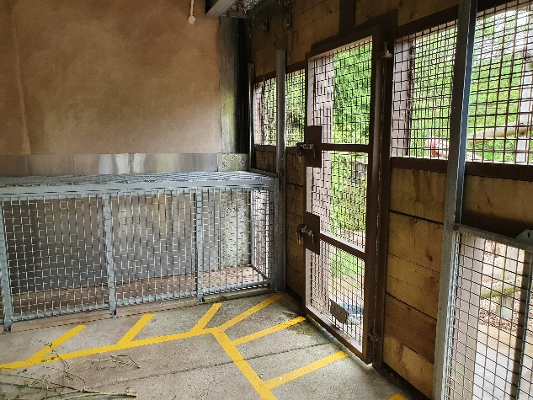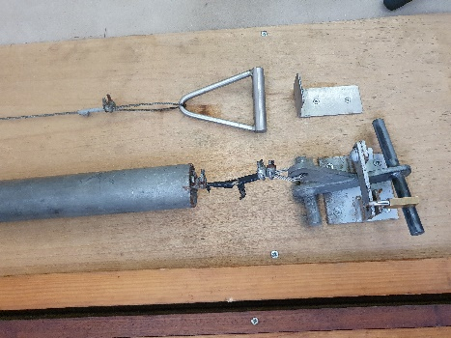

Feeding/Enrichment
Sun bears are an intelligent species and can pick up on keeper routines, so keepers have to keep things as unpredictable as possible. The bears are given a total of 9kg fruit and vegetables daily along with pellets and insects. Keepers roll a dice first thing in the morning (it has numbers from 2-6) to determine how many feeds they give each day. Timings of feeds are randomised by the keeper that day. The bears have several additional items to their diet, given on a regular basis, such as honey, peanuts, raisins and porridge. As sun bears are omnivores, in the wild they might eat small mammals, birds and eggs. Here these are offered on occasion as they have never shown much interest. There are multiple water drinkers in all areas of the enclosure.
Food can be presented as scatter feeds or within enrichment items. This encourages the bears to forage and spend longer feeding. Keepers can provide food from inside the enclosure when cleaning, or can throw in from outside the enclosure. There are two locations they can do this, one is a tall ladder located near the top of the outside enclosure and has a small platform for keepers to stand on. The other is a ‘roof garden’ which is located above the bottom public viewing area and reaches from the right side to the left side of the enclosure. This allows keepers to scatter food over the entire enclosure. Keepers can offer food in all three areas of the enclosure as well.
Keepers provide a variety of enrichment on a daily basis. This aims to encourage the bears to display natural behaviours such as foraging, digging, climbing and use of tongue and claws. Such enrichment includes items made from firehose, barrels, boomer balls and PVC pipes which can be cleaned and re-used on a rota basis. Other items are destructible and includes cardboard boxes, hessian sacks and bamboo. Natural items such as rotten logs are also used. Enrichment is provided in all areas of the enclosure. Once a month fish is provided as a novel scent enrichment for the bears. Other scent enrichment such as perfumes, herbs and spices are also used.

Training
Keepers undertake training with the sun bears in order to aid any medical procedures or veterinary concerns. This helps if keepers need to administer any medication and also allows keepers to visually check the bears on a regular basis. Training offers a different form of mental stimulation for the bears and strengthens their bond with keepers. The bears can be trained in different locations, such as in the dens or from the training wall at the bottom of the outside enclosure.
The bears have learnt various behaviours; this includes target training, open mouth behaviour, presenting chest and lay down. The bears are also weighed on a regular basis and the training helps with this.

Public area & Interpretation
There are two viewing areas for Bears of the Rising Sun. The top area consists of a ramp leading up to a large viewing window of the outside enclosure. Along the ramp there is information about the bears here at the zoo and their history. On the left there is an example bile crate to educate visitors about the bile trade and threats that sun bears face in the wild. On the right, this leads into an indoor viewing area with windows to both the outside enclosure and indoor house. There are lots of facts about sun bears here and the area also provides viewing of the Rufous Hornbills. At the entrance to this top public area, there are clocks which keepers will change daily, for encounters. Currently two of these clocks are in use. Encounters can be a feed, enrichment, keeper talk or training session and keepers will talk about Action for the Wild and have the opportunity for donations from the public.
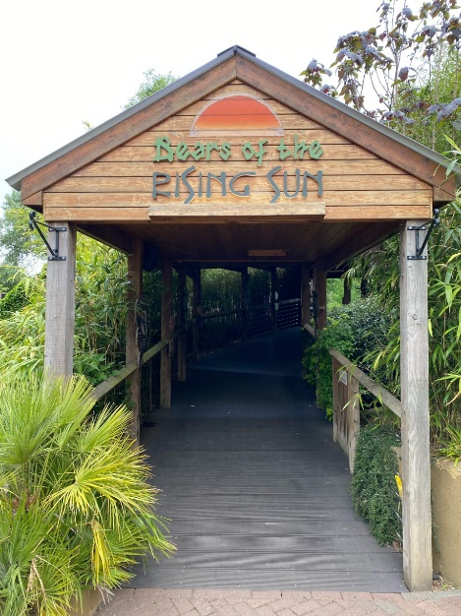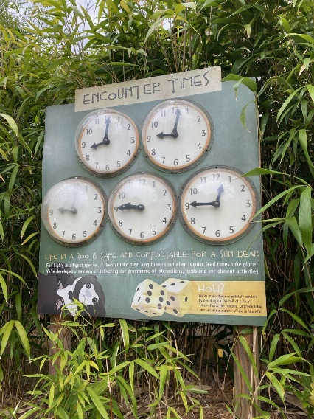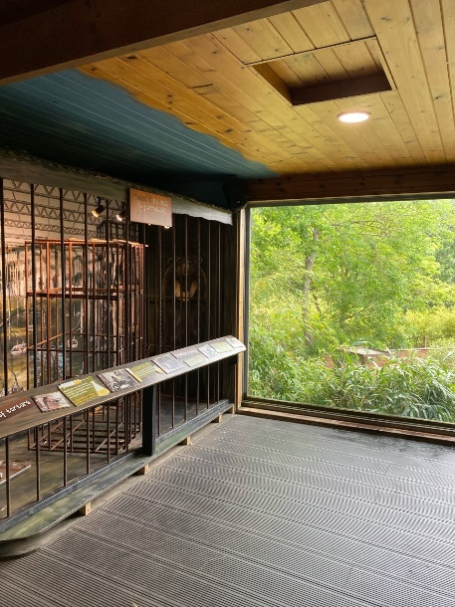
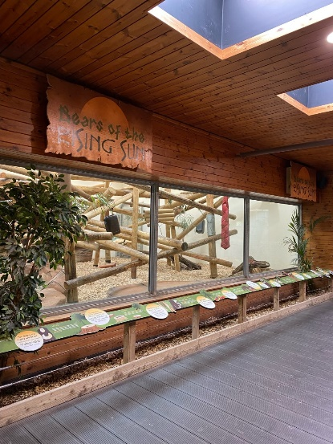
The bottom viewing area extends the width of the enclosure, with large viewing windows, including the underwater viewing window. There is extensive interpretation that visitors can interact with, such as size comparison of different bear species and mirrors to allow visitors to compare themselves to the anatomy of a sun bear. There is more information about the threats sun bears face here as well.
