Ostrich Feather Structure and Quality
There are many different types of Ostrich Feathers depending on the age of the bird, the sex of the bird and where they are positioned on the bird.
Figure 1 explains the following terms and illustrates various defects that may be present in an ostrich feather. A feather consists of a Plume (the larger part of the feather) and the Quill (the naked stalk at the bottom end of the feather). A Plume consists of a Shaft (rachis) with branched Barbs on which Barbules are found. Every Barbule has a Base and a Pennulum, on which minute spikelets (Barbicels) are found, which are called Fila, without the normal Hooklets (Pyecraft, 1898). These Hooklets would normally hook onto the Hooklets of adjacent barbs’ Barbules to form a network in perching birds. The bases of the barbules of all flightless birds are twisted. A single Barb with Barbules is called a Plumule, and all the Plumules together is the Flue. A single Plume has a Butt (at the point closest to the base) and a Tip (at the point furthest from the base).[1]

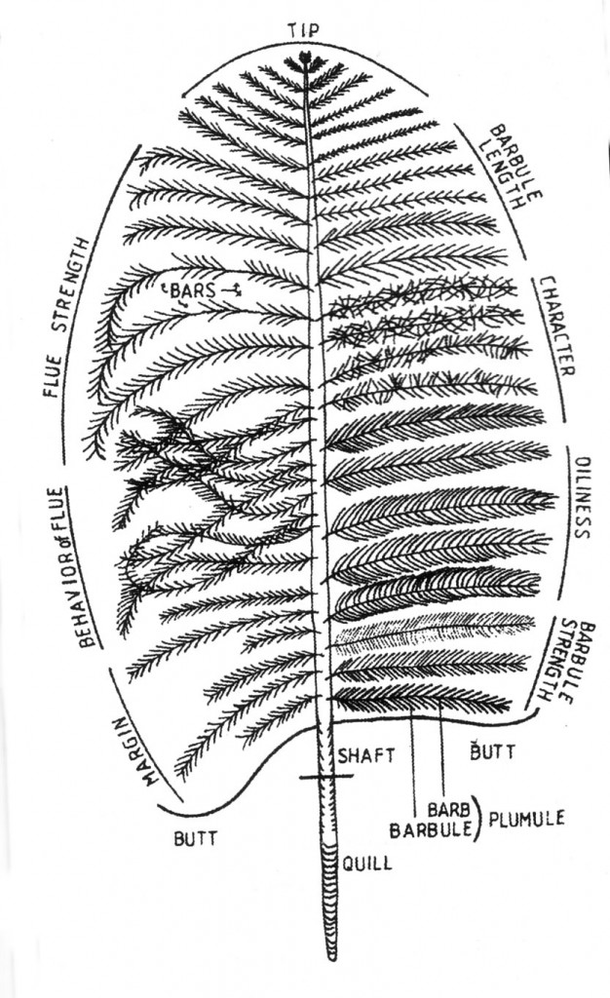
Figure 1: Ostrich Feather Drawing illustrating definitions, terminology and and some defects (compiled from Swart, 1979)

