Ussuri Falls
Family: Species: Common Name: Capacity:
Felidae Panthera pardus orientalis Amur Leopard 1.1.4
2 enclosures

Description
Ussuri Falls consists of two adjacent enclosures, connected by a ‘mixing area’ used when breeding. One enclosure holds the breeding male, Crispin and the other holds the breeding female, Esra. Her enclosure would also hold any cubs until of a dispersal age.
The objectives of the Amur leopard exhibit are to maximise the breeding potential of the leopards and to engage and inspire visitors to help conserve the species in its native habitat as it is a critically endangered species. Through Colchester Zoo’s charity Action for the Wild, the zoo helps to support Wildlife Vets International.
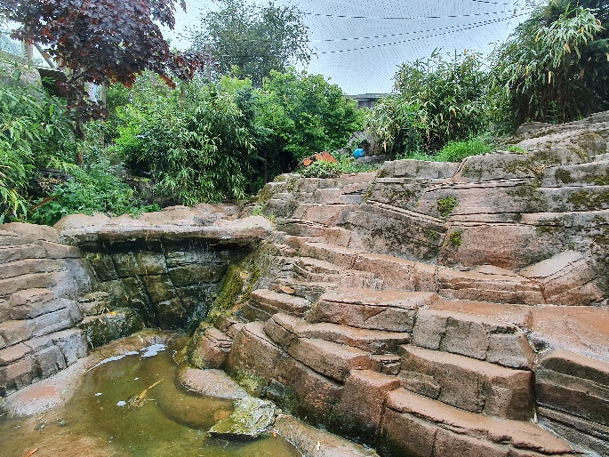
The male’s enclosure is situated at the top of leopard hill, opposite the entrance of Billy-Jo’s path. The female’s enclosure is to the left of the hill, situated opposite the spider monkey enclosure and with the Giant Anteater enclosure on the other side.
The male’s exhibit consists of an outside enclosure and an indoor house. The female’s exhibit consists of an outside enclosure, multiple indoor areas, some of which are off-show, along with an outdoor off-show area and cubbing area. Leopards have access to all these areas all of the time except when keepers are cleaning. The only exception is to the ‘mixing area’ which they only have access to when breeding. Keepers have CCTV cameras in the mixing area and cubbing area for breeding purposes.

Male Leopard Enclosure
The outside area is enclosed by mesh walls and roof as they are a climbing species. Keepers check the perimeter daily and maintain vegetation. This is a barked area with two small natural pools. There are several platforms with connecting beam structures to allow for climbing and utilise the height of the enclosure. Keepers can secure a range of enrichment to these beams and platforms. There is a cave area which provides a more enclosed space, which a leopard might feel more comfortable eating in and keepers see the male do this on a regular basis. A selection of large logs are used in the enclosure to offer scratching places and areas for keepers to hide food or enrichment. Lots of vegetation, including bamboo, maple trees and large grasses all offer shelter and privacy from visitors. There is also access to an off-show tunnel/crush system which keepers can give the leopard access too when using for training purposes. The indoor house is accessed by two slides from the outside enclosure.
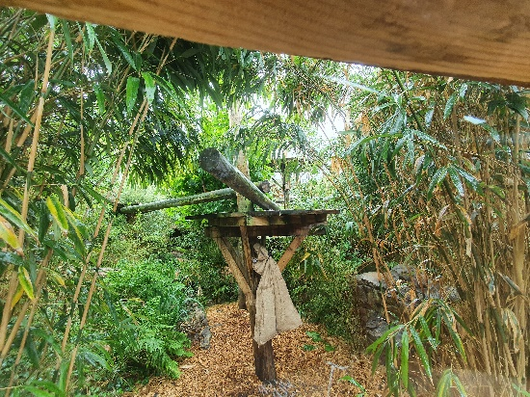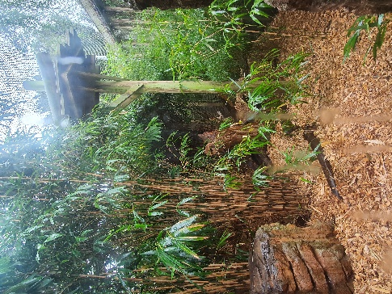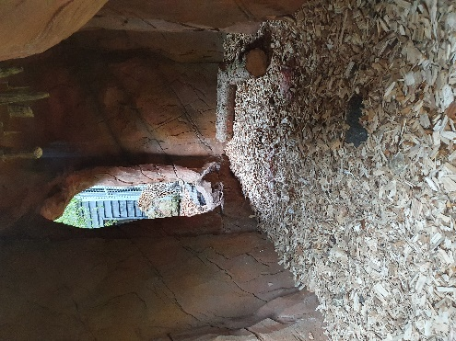
The indoor house consists of two separate dens, with a dividing slide between them. This slide is always open unless keepers have a need to close for any reason. This has a tiled floor which is easy for keepers to clean and maintain. There are wooden shelves in both sides of the house, which provide a place to rest at height. Keepers provide straw beds in both sides so the leopard has the choice of where to go. There is no heating system in place but windows, traps and fan for ventilation during the summer. Natural light is provided by the two large viewing windows. Keepers can provide enrichment and food in this area if needed.
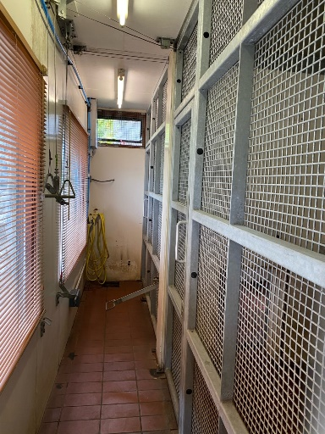

Female Leopard Enclosure
The outside area is enclosed by solid concrete walls with mesh roof. Keepers check perimeter daily and maintain vegetation. This area has a natural floor, of dirt, grass and other vegetation along with rockwork. There is a platform on the left perimeter wall with viewing window and the leopard accesses this from the surrounding wall. This allows a place to rest at height and away from visitors. Underneath the platform, there is a large mesh gate, which keepers can use as a training wall. This is normally covered by a roller shutter door when not in use. There is a large waterfall and pool in the enclosure. This has a pump system operated by keepers from outside of the enclosure. A selection of large logs are used in the enclosure to offer scratching places and areas for keepers to hide food or enrichment. Some of these also offer additional resting places and keepers often seen her using these. Lots of vegetation, including bamboo and maple trees all offer shelter and privacy from visitors. There are plenty of smaller shrubs as well. Keepers can utilise the trees in the enclosure for hanging food or enrichment items. The indoor area is accessed by a slide at the bottom right of the enclosure.
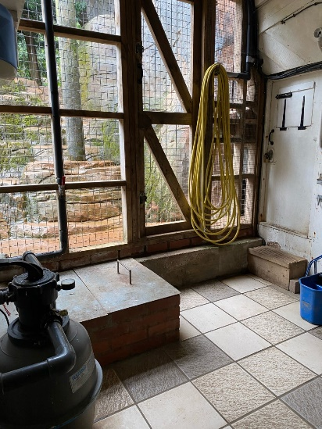
There are multiple indoor areas and tunnels connecting these. One of these tunnels also has facilities to act as a crush if needed. There is a small tiled area which leads onto a larger cave area which has public viewing windows. Keepers keep the area dark so as to offer privacy. A straw bed is provided here which is regularly used. It also offers a cool area for the leopard to relax in during hot weather. The tiled area also leads onto the off-show cubbing den via a tunnel. This is a small enclosed space to provide security for a mother and cubs. There is a shallow sided cubbing box with straw provided. This would be an ideal place to give birth. There is a heater enclosed in a mesh case which can be operated from outside the enclosure by keepers as well as lighting. There are CCTV cameras in this area allowing keepers to observe remotely without disturbance to mother and cubs. This then leads into a small off-show outside area, designed for cubs to develop before tackling the main outside area. This is a barked area with a raised concrete area, and contains multiple bamboo plants and logs. This is also mesh roofed. All these areas can be isolated via a number of slides if necessary.
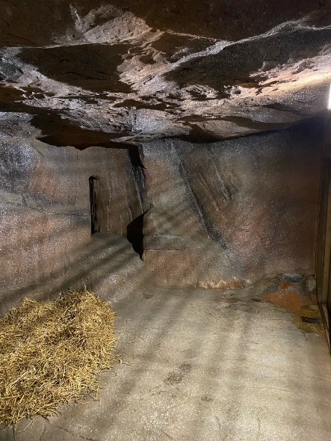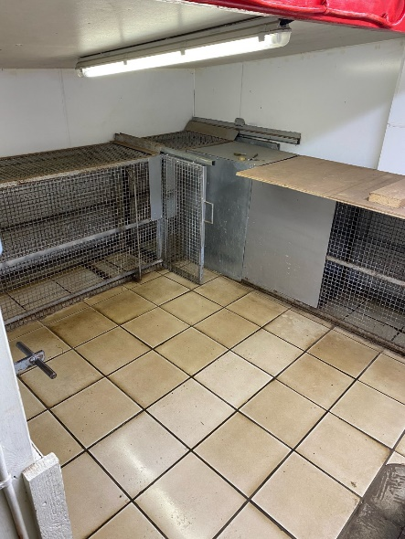

Mixing Area
This area is situated between the top of the female’s enclosure and to the side of the male’s enclosure and connects them together. It is a tiled area with a full mesh wall on the female side. There is a small mesh window on the male side. There are two solid slides, one leading into each enclosure. This area is designed to allow slow introduction of leopards for potential breeding. Keepers monitor both leopards behaviour in this area by CCTV which is accessed outside of the enclosure. This allows them to determine the optimal time for introduction.

Keeper areas
Keepers predominantly prepare all carnivore food at the Animal Kitchen, but have small preparation spaces at each enclosure if needed. There is space to store enrichment items. There is also controls for heating, lighting and CCTV in these areas.

Security & Management
Amur leopards are a Category 1 animals which means that keepers operate with a lock checking protocol and always work in pairs when moving the leopards between areas. Leopards move easily between areas, using a recall and are given a food reward. Keepers never enter the same area as the leopards. They will secure each leopard in one of their respective areas in order to service the other area. For example, the female leopard can be recalled into her house, two slides are closed and secured with padlocks. Keepers always aim to have two slides between themselves and the leopard. Both keepers will check all slides and padlocks, as well as checking that the leopard is where she is supposed to be, before entering into the outside area. Similar systems are in place in all areas of both leopard enclosures. All slides, pulleys, mechanisms and doors are regularly checked by welders as well as keepers to ensure safe working

Feeding/Enrichment
As they are a carnivore species, keepers provide a variety of meat, including chickens, rabbits, deer and horse. They also aim to provide meat with fur, bones or feathers in order to offer a natural feeding behaviour. They are usually fed once daily but keepers aim to feed at different times each day. Food can be presented in various ways, including tied up, scatter feed or hidden in enrichment items.
Keepers provide a variety of enrichment on a daily basis which aims to encourage natural behaviours. Such enrichment includes many different scents, for example perfumes, herbs and spices, which keepers often see leopards interact with. Other enrichment includes firehose items, barrels, footballs which can be cleaned and re-used on a rota basis. Destructible items are also provided such as cardboard boxes, hessian sacks and paper sacks.

Training
Keepers undertake training with the leopards in order to aid any medical procedures or veterinary concerns. This helps if keepers need to administer any medication and also allows keepers to visually check the leopards on a regular basis. Training offers a different form of mental stimulation for the leopards and strengthens their bond with keepers. The female leopard can be trained at the training wall. This wall is on the left side of the enclosure under the platform. It is a mesh wall, covered with a roller shutter door when not in use. The male leopard can be trained in his house area or tunnel/crush area.
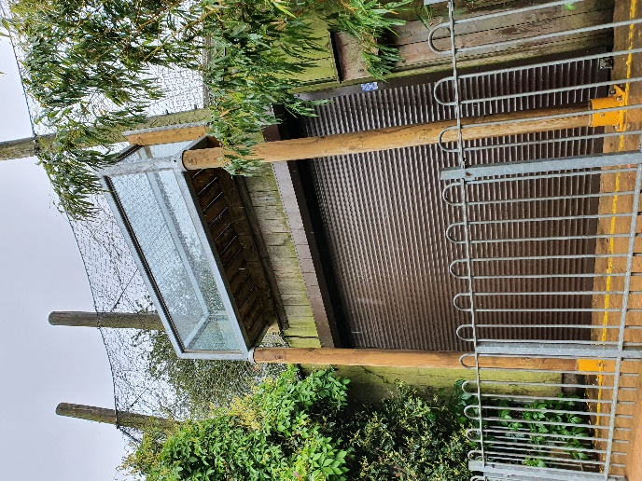
The leopards are weighed on a regular basis and their training helps with this. Other behaviours they know include target training and lay down. Due to the fact the enclosure is designed for a breeding pair, keepers take a step back from interaction like training when breeding.

Public area & Interpretation
There are multiple viewing areas for Ussuri Falls. At the female’s enclosure there is a large viewing window at the bottom of the hill, into the outside enclosure, with interpretation signage. There are mesh sensory windows on the left side of the enclosure and further viewing from cave windows at the top of the enclosure, accessed by the male’s enclosure which allow for visitors to feel immersed. There is also a badge machine, which raises awareness of the threats leopards face in the wild, whilst raising money for Action for the Wild. Keepers also do an encounter for the leopards, which can be a keeper talk, feed or enrichment. They will talk about Action for the Wild and have the opportunity for donations from the public.
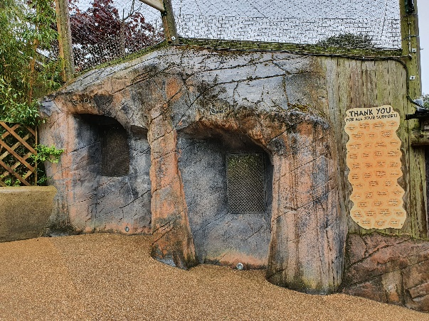
At the male’s enclosure there are multiple windows to view his outside and inside areas. There is another viewing window into his cave area and he also has three mesh sensory windows. These can be accessed by the red panda viewing area.
