**Biofact information**

* **Buffalo horn** - Male water buffalo have horns that curve backward. These horns can grow to 5 feet (1.5 meters) long. Females also have horns, but they are much smaller. Horns are permanent whereas antlers are shed each year and regrow. Live in tropical forests of Asia
* **Reindeer antler -** Males and females have antlers. Antlers are like fingerprints no two are the same. Live up to 15 years. North America including Canada and Alaska also in Europe, Russia and Greenland. Reindeer antlers are actually rubbery, living masses of blood and marrow when they are growing. The antlers grown until around August, then the bone begins to harden.

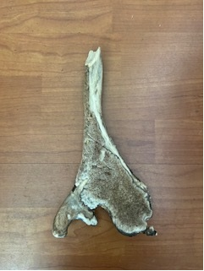

* **Elephant tooth** - above black line is above the gum, constantly wearing teeth down as grinding with the. Teeth always growing. They grow from the back of the jaw and move down, as they are worn down they are eventually replaced and fall out. An elephant gets 6 sets of teeth across their life.

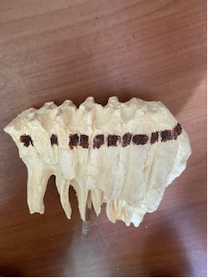

* **Dik Dik fur** – these are some of the smallest hooved animals on earth. The name dik-dik comes from an onomatopoeia of the repetitive dik sound female dik-diks whistle through their long, tubular snouts when they feel threatened. Dik-diks have special physiological adaptations to help them survive in arid environments. For instance, dik-diks have a lower density of sweat glands compared to other animals such as cattle. Similarly, in more arid environments, dik-diks can concentrate their urine. These adaptations help dik-diks preserve body water

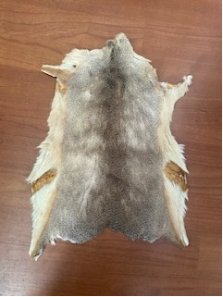

* **Lion skull –** Of the living felid species, the lion is rivalled only by the tiger in length, weight, and height at the shoulder. Its skull is very similar to that of the tiger, although the frontal region is usually more depressed and flattened and has a slightly shorter postorbital region and broader nasal openings than those of the tiger. Due to the amount of skull variation in the two species, usually only the structure of the lower jaw can be used as a reliable indicator of species. Skeletal muscles of the lion make up 58.8% of its body weight and represents the highest percentage of muscles among mammals.

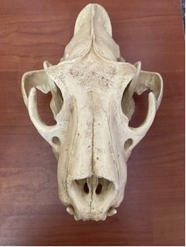

* **Turtle shell** - upper shell called carapace. Sea turtles cannot hide their head in their shell making them more vulnerable to predators. Sea turtles spend most of their life in the ocean. During nesting season the female will return back to the same beach where she was hatched. She will find the right beach even after 30 years of absence.

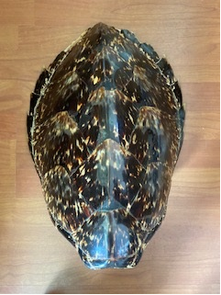

* **Tortoise shell -** is made of keratin like out fingernails. The lighter the shell colour the warmer the climate the animal came from. Shells have nerve endings, so tortoises can feel every rub, pet, or scratch ... and sometimes they love it.

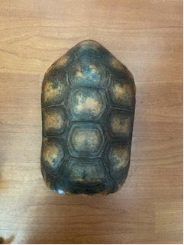

* **Giraffe vertebrae** - same number as humans 7 however unlike humans they can be 10 inches’ long. Giraffe almost never **sleep** for longer than five minutes at a stretch in the wild, often modifying the position so that they remain standing with their head and neck curved around to rest on their hindquarters.

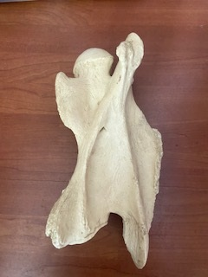

* **Macaw feather** – scarlet macaw. A flight feather, noisy when flapped in air.
* **Flamingo feather** – pink. Colour is from the diet of tiny shrimp they eat. Sometimes grey feathers when not eating the shrimp.
* **Ostrich feather** – not for flying. For enhancing appearance during courtship dances and keeping eggs cool.

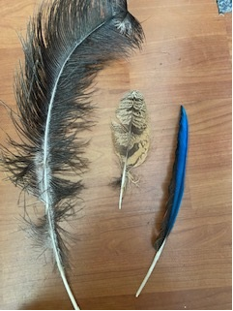

**Biofact Top tips & starters for prop parade**

* Choose a prop from the Volunteer hub and put it in a rucksack.
* Take some stickers and a people counter to record how many people you use the prop to interact with.
* Head out anywhere in the Zoo – near an appropriate enclosure the prop is related to is fine, but you could use it anywhere.
* After introducing yourself, hold the prop out and invite people to have a look without telling them what it is. Start off with a teaser – *‘come and have a look and touch of this item and together we can figure out what it is’ or ‘do you think we could find out about this animals habitat just by its shape’ (turtle shell and adaptations for water)*
* The aim is to answer visitor questions with another question and get them using what, where, when, why and how questions to explore the object;

**(Elephant tooth)**

Visitor- What’s that?

You – What do you think?

Visitor – a bone?

You - Do you think it could be a bone? Where in the body might it be found? After exploration - not a bone.

You - What would the animal use it for? Describe the shape to me, do you have anything like that but a lot smaller you use to do something important with food?

Visitor – a tooth!

You – how do we know what food they eat just by looking at the shape?

* So remember the questions you can ask the visitor – how does the animal use it? Where on body is it found? Why do they have it there? When do they use it? How do they use it? What can of food would a tooth like this be used for? Why do think this feather is silent when you flap it? How would you feel with a horn that heavy on your head? Etc etc.
* Give visitors a sticker and remember to tell them what it is in the end!