This is because to my greatest delight, I had discovered today a wonderful book. It is called The Felidæ of Rancho La Brea (Merriam and Stock 1932, Carnegie Institution of Washington publication, no. 422). As the title suggests it goes into details of felids from the Rancho La Brea, in particular Smilodon californicus (probably synonymous with S. fatalis), but also the American Cave Lion, Panthera atrox. The book is full of detailed descriptions, numerous measurements and beautiful figures. However, what really got me excited was, in their description and comparative anatomy of P. atrox, Merriam and Stock (1932) provide identification criteria for the Lion and Tiger, a translation of the one devised by the French palaeontologist Marcelin Boule in 1906. I have forever been looking for a set of rules for identifying lions and tigers and ultimately had to come up with a set of my own with a lot of help from cat experts. So that is why I was so excited to find this unexpected treat in this book. What's even better is that a glance through Boule's criteria (Merriam and Stock 1932) showed that I'd derived at about 80% of it already. Not bad, not bad at all.
So here are the criteria of Boule (1906) as translated and presented by Merriam and Stock (1932). I shall only list the cranial characters. Alongside are my identification criteria as shown in a series of diagrams I'd prepared for the Departmental collections, for potential use in undergraduate practicals - I used subadults for this, as the unfused sutures come up more visibly in photos.
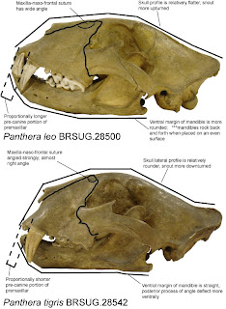LION
1. The frontal process of the superior maxillary reaches the level of the fronto-nasal suture, or extends back of this suture.
2. The summit of this process is more or less acute.
3. The nasal bones are flat or slightly convex, especially toward their frontal extremities.
4. The external opening of the nasal fossae is relatively wider; it widens regularly beginning at the lower part.
5. The interorbital space formed by the frontals is wider, flatter and even commonly excavated; the Lion has a forehead which is wide and flat, transversely as well as longitudinally.
6. The temporal part of the frontals is relatively less developed; the fronto-parietal sutures are placed further forward.
7. The posterior palatine foramen is closer to the orbital border.
8. The inferior border of the mandible has a rather convex form; below the carnassial, this border presents a sort of tuberosity which is more or less pronounced (ramal process of English authors). This shape is such that a mandible of a Lion lying on a table on this inferior border can not touch the table at the symphysis and the angular process at the same time.
9. The coronoid process does not project behind the condyle.
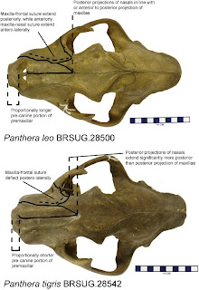TIGER
1. The frontal process of the superior maxillary does not reach the fronto-nasal suture.
2. The summit of this process is truncated.
3. the nasal bones are very convex throughout their length.
4. The external opening of the nasal fossae is relatively narrower; it widens regularly, only up to a certain height, beginning at the lower part.
5. The interorbital space is narrower and always convex: the Tiger has a forehead which is narrower and more arched.
6. The temporal part of the frontals is relatively more developed; the fronto-parietal sutures are placed further back.
7. The posterior palatine foramen is further removed from the orbital border.
8. The inferior border of the mandible has a rather straight and even concave form; there is no tuberosity below the carnassial. The mandible placed on a table rests on the symphysis and on the angular process at the same time.
9. The coronoid process projects behind the condyle.
(Merriam and Stock 1932, pp. 181-182)
With regards to my diagrams featuring my identification criteria, most of Boule's (1906) criteria are actually featured here, albeit in simpler language. The most immediately notable difference between a Lion and a Tiger skull is shown best in the lateral view photo. The Lion skull (top) is generally flatter and the face is upturned. On the other hand, the Tiger skull (bottom) has a rounded look to it with the face tilted sharply downwards. When the skull + mandible is placed squarely on a 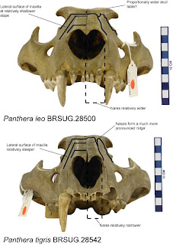flat surface, the Lion skull will rock forwards and backwards, primarily due to the rounded ventral margin of the mandible, the tuberosity below the carnassial (m1) as described by Boule (1906). The Tiger skull on the other hand will just sit there firmly.
The most noticeable difference between the two taxa in dorsal view is the relative positions of the maxillo-frontal and naso-frontal sutures. In the Lion, the apex of the nasals are either in line with the apices of the frontal processes of the maxillae or more anterior to these, while the same nasal projection extends farther posteriorly in the Tiger. The shape of the frontal process of the maxilla also differ in the two species as described by Boule (1906). After the gross differences identifiable from lateral view, which is basically the same as first impressions, the relative positions of these sutures is the most reliable and concrete distinguishing character.
In frontal view (below), the Lion has a relatively wider external opening for the nares, flatter dorsal surface of the nasals, less steeply inclined lateral surfaces of the maxilla, and broader forehead. The Tiger on the other hand has a narrower external nasal opening constricted ventrally, strongly convex dorsal surface of the nasals such that it forms a prominent bridge along the lateral margin of the nasals with a concave valley along the midline, steeply inclined lateral surfacese of the maxillae and relatively narrower forehead. Overall, a Lion is broader and flatter along the bridge of the nose, while the Tiger is narrower and sharper along the bridge of the nose.

